Mrs. Green’s Gazette:

October 28, 2019

IMPORTANT DATES:
- Half Day of School: Thursday, October 31st. Dismissal at 11:36.
- No School: Tuesday, November 5th: Staff Development / Election Day
- No School: Wednesday, November 27th – Friday, November 29th for Thanksgiving. School resumes with a late start Monday on December 2nd.
- Picture Retake Day: TOMORROW, October 29th. You must bring in the originals.
- Sunrise Nursing Home: Both second grade classes have a partnership with Sunrise Nursing Home located right by the Mobile Gas Station. We alternate walking there once per month to do a project with them and lift their spirits. This month we will begin by walking there this Wednesday, October 30th around 10:30am and plan to be there for about 30-45minutes. Thank you for sending your child in with comfortable shoes and appropriate weather clothing.
- Math Test: Wednesday, November 6th. Please look for the review to come home Monday evening (No school on Tuesday, November 5th – election day).
- Late Start Monday’s: School begins at 9:05am and dismissal remains the same
  - November 4, 11, 18, 25
  - December 2, 9, 16
- Specials for the week:
  - Monday: Library
  - Tuesday: Music
  - Wednesday: Gym
  - Thursday: No specials – half day Halloween
  - Friday: Library
- PTO Events:
  - 11/4: Mason Night at Ferlito's
  - 11/19: Mason Night at Jet's
  - 12/7: Mason Night at Jet's

Halloween Information –
- Halloween is this Thursday, October 31st. It is a HALF DAY for students! All are welcome to join our party and watch the parade. If you would like to take your child home after the party, you are welcome to do that as well. Please note the schedule below.
  - 8:45-9:30 Parade
  - 9:30-10:30 Classroom Parties
  - 10:30-11:15 Assembly
  - 11:15-11:30 Pack up and go home

WORD STUDY:
Due to Halloween this week we will NOT have new spelling words! Enjoy the week off
READING WORKSHOP:
This week, students will be revisiting strategies of how to solve challenging words. Specifically, we will focus on stopping if a word doesn’t make sense, rereading for meaning and looking for parts in the word that can help. We will also engage in a few fun Halloween reading activities!

WRITING WORKSHOP:
We have finished our first small moment stories and taken them all the way through the writing process. This week we will be doing some fun Halloween writing!

MATH:
We will be finishing up unit 2 this week. Our unit 2 test will be on Wednesday, November 6th. Please look for a completed review to come home Monday evening (no school Tuesday, November 5th – election day).

SOCIAL STUDIES:
We are continuing our Civics Unit. This week we will read two stories: The Big Orange Splot and Old Henry where students heard about the core democratic value of liberty. Talk with your child about what liberty and common good mean.
- Common Good: means that people make laws / rules that should be good for all of us.
- Liberty: means that we can choose our own friends, jobs, have our own ideas and what we say in public as long as it does not hurt others.

OTHER IMPORTANT INFORMATION:
- If you’re interested in being a MYSTERY READER in the month of November, please let me know what date might work for you!
- This is the time of year when weather can be all over the map! Layers are great so we can shed them throughout the day as it gets warmer.

Your partner in education,
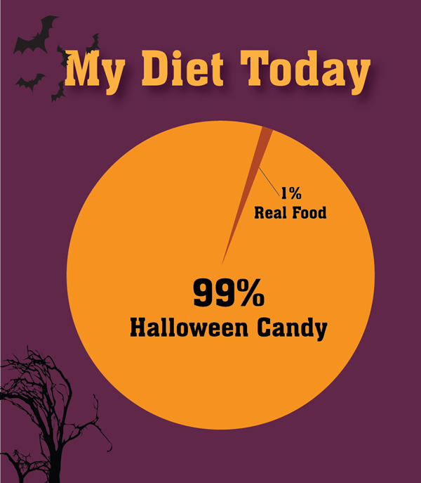
Mrs. Green

