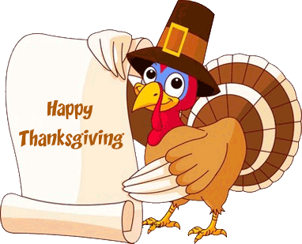
Mrs. Green’s Gazette:

November 18, 2019

IMPORTANT DATES:
- No School: Wednesday, November 27th – Friday, November 29th for Thanksgiving. School resumes with a late start Monday on December 2nd.
- Late Start Monday’s: School begins at 9:05am and dismissal remains the same
  - November 25
  - December 2, 9, 16
- Specials for the week:
  - Monday: Gym
  - Tuesday: Art
  - Wednesday: Library
  - Thursday: Music
  - Friday: Gym
- PTO Events: Be sure to mention Mason
  - 11/19: Mason Night at Jet's
  - 12/11: TCBY Night
  - 12/17: Mason Night at Jet's
- Holiday Concert: The holiday concert will be on Wednesday, December 11th
- Merry Morning at Mason: December 7th
- Report Cards Home: December 10th
- Red / Green / Holiday Spirit Day: December 19th
- Pajama Day: December 20th

WORD STUDY:
Students will be given the following 5 words and will need to correctly spell them for their quiz on Friday morning. Please practice using these words throughout the week.
Spelling Words: next, each, have, our, people
Challenge Words (only if you want!): cornucopia, pilgrims, thankful, Thursday

READING WORKSHOP:
This week, students will continue to think about characters within the stories we read. We will focus on using character traits to describe characters and will read a variety of mentor texts to help guide our thinking. Our shared reading for the week will be Officer Buckle and Gloria.

WRITING WORKSHOP:
This week students will be working on main idea and details writing through activities surrounding Thanksgiving.

MATH:
We will continue Unit 3 this week. We will learn a new game called Salue that will help us practice our math facts. Please continue practicing addition and subtraction facts at home.

SOCIAL STUDIES:
We are finishing up our Civics Unit this week. Our civics test will be on Friday, November 22nd. Please look for a completed review to come home on Thursday evening to help you review with your child.

CHARACTER FOCUS: We will begin talking about putting first things first, habit #3 this week. Students will learn this means we work first, then play.

OTHER IMPORTANT INFORMATION:
- The snow came early! Please be sure your child is sent with snow pants, boots, gloves and hats each and every day.
- If you’re interested in being a MYSTERY READER in the month of November, please let me know what date might work for you!

Your partner in education,
Mrs. Green

