Mrs. Green’s Gazette:

November 25, 2019

IMPORTANT DATES:
- No School: Wednesday, November 27th – Friday, November 29th for Thanksgiving. School resumes with a late start Monday on December 2nd.
- Late Start Monday’s: School begins at 9:05am and dismissal remains the same
  - December 2, 9, 16
- Specials for the week:
  - Monday: Art
  - Tuesday: None – Half day of school
  - Wednesday: No school
  - Thursday: No school
  - Friday: No school
- PTO Events: Be sure to mention Mason
  - 12/11: TCBY Night
  - 12/17: Mason Night at Jet's
- Holiday Concert: The holiday concert will be on Wednesday, December 11th
- Merry Morning at Mason: December 7th
- Report Cards Home: December 10th
- Red / Green / Holiday Spirit Day: December 19th
- Holiday Party: Thursday, December 19th in the afternoon. Time and details TBD.
- Pajama Day: December 20th

WORD STUDY:
No spelling words this week! Happy Thanksgiving!

Our regular curriculum will continue after Thanksgiving. Enjoy the holiday with your families!

OTHER IMPORTANT INFORMATION:
- The snow came early! Please be sure your child is sent with snow pants, boots, gloves and hats each and every day.
- If you’re interested in being a MYSTERY READER in the month of November, please let me know what date might work for you!
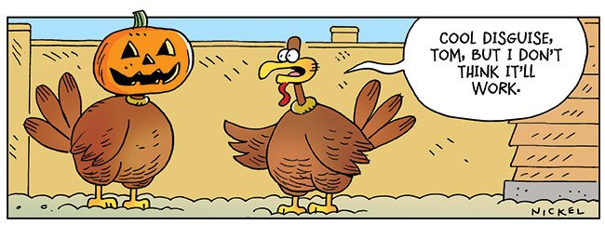
Your partner in education,
Mrs. Green

