Technology in Second Grade
Throughout this year, it is important for us to stay in contact and have open communication about what is happening at Mason and in room 207. Please read the below information to help you get started and stay connected!
Remind 101
Why:
- To quickly send out announcements and reminders to the entire class

How:
1. Take out your cell phone
2. Text the number (586) 480-2341
3. In the text type @86kgba
4. You will receive a text message back that asks you if you are a student, parent or teacher. Reply P for parent.
5. You have then joined our classroom group and will receive an addition text message from a different number. This number is where all reminds will come from. You can choose to save this number in your phone as something such as “2nd grade” or “Mrs. Green Reminds.”
6. You do NOT need to download the app. All reminds will come via texts.
7. Note: you cannot respond to the text. Its purpose is for me to get important information out to you.

Twitter
Why:
- To post reminders about events
- To share news of the day / week (show what we know!)
- To share photographs and information from school-wide activities and class trips
How:
1. Sign up for a Twitter account if you do not already have one by heading to www.twitter.com
2. Follow me at @greengina87
3. Use our classroom hashtag #teamgreen17 in all of your tweets

Website
Why:
- To access information like weekly newsletters, spelling lists and IXL skills
- Quick access to commonly used websites for students
How: Log onto this website www.mrsggreen.weebly.com from any computer or mobile device and you can access the weekly newsletter, spelling words, bell schedule, Mason phone numbers, etc. There is also a BLOG feature that allows you to communicate with other parents in our classroom and leave comments about events in our classroom or building.

Email
Email is a great way to communicate. Please allow for 24 hours for me to respond to each email. Occasionally I will send out whole class email blasts with important information. greeng@gpschools.org
Other
Throughout the school year students will have the opportunity to work with the ipads and on the computers to assist their learning both at school and at home. Please look for individual logins, passwords and general information about the technology we are using both in school and at home throughout the year.
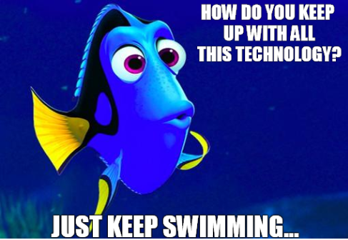
Thanks!
Gina Green

